**6. Particle in a Box**

Concerns a simple system. It shows how QM applies; and how the just introduced postulates work. Also provides a crude approximation to π-electrons in a linear conjugated hydrocarbon molecule. (Text Ch. 4).

**1-D Box ⭢** keeps Mathematics simple; e.g., an atom confined on the x-axis between impenetrable walls.

V = ∞

V = ∞

V = 0

0

a

x

**Potential Energy** is infinite outside the region of width a

**∴** Mathematically, V(x) = 0 for region 0 < x < a and V(x) = ∞ for x ≤ 0 and x ≥ a

**Introduce the SWE:**

**TISWE:**  [If present, 

For 0 < x < a:  since V(x) = 0 here

i.e., in this region, 

This Differential Equation (DE) has the general solution

ψ(x) = A Cos (kx) + B Sin (kx), where A and B are constants.

Outside the 1-D box: the second derivative of ψ(x) would be infinite if the wave function was not zero for all x values outside the region of the box, i.e., **because d2ψ(x)/dx2 must exist and be well behaved**, ψ(x) must be zero outside the box and because the wave function **ψ(x) must be continuous**, ψ(at x = 0) = ψ(at x = a) = 0. These are the **boundary conditions** that any well-behaved wave function for the particle in a 1-D box must satisfy.

The boundary conditions place **constraints on ψ(x)** and enable us to solve the equation**.**

**∴** At x = 0, 0 = ψ(0) = A Cos [k(0)] + B Sin [k(0)] = A (1) + B (0) = 0 → A = 0 since ψ(0) is 0.

**∴** At x = a, 0 = ψ(a) = 0 Cos k(a) + B Sin k(a) = B Sin ka = 0.

But we don’t want ψ(x) to be 0 everywhere → ka = nπ or k = nπ/a where integer n = 1, 2, 3, **but it is not 0** since then ψ(x) would be zero everywhere;

i.e., a **quantization condition results;** we require an integer value for n & that n ≠ 0.

**∴ Acceptable wave functions** take the form:

$ψ_{n}\left(x\right)=\text{B Sin}\left(\frac{n⋅π⋅x}{a}\right)\text{ where n }=\text{ 1, 2, 3, 4, .......}$ but is not 0 (see above)

where each different **n** corresponds to a **different eigenfunction ψn** and each of these eigenfunctions corresponds to a **different energy. [Spring 2021]**

**What is the energy? Since, $k^{2}=\frac{\text{2mE}}{ℏ^{2}}\text{from above}→ \text{E }=\frac{ℏ^{2}k^{2}}{\text{2m}}=\frac{ℏ^{2}}{\text{2m}}\frac{n^{2}π^{2}}{a^{2}}=\frac{n^{2}h^{2}}{\text{8 m }{\text{a}}^{2}}$**

**B** is obtained from the Normalization condition, i.e. it is obtained from,

$\int_{x=0}^{a}{ψ_{n}^{*}\left(x\right)} {\text{ψ}}_{n}\left(x\right)\text{ dx}=\text{B*B }\int_{0}^{a}{\text{ Si}{\text{n}}^{2}\left(\frac{n⋅\text{π} ⋅x}{a}\right)}\text{ dx}$. **Please Determine B Now.**

[How? Use a variable substitution (put z = n π x/a) and use the standard integral $\int{\text{Si}{\text{n}}^{2}\left(\text{by}\right) }\text{dy}=\frac{y}{2}-\frac{\text{Sin }\left(\text{2by}\right)}{\text{4b}}$].

**Note the following:**

(1) **Energy** for the particle **can take on only discrete values** – it is **quantized**.

(2) The **lowest energy is greater than 0!!!!** – i.e., there is **a zero-point energy** when n = 1.

(3) **Energies** for the allowed states increase as **n2**.

(4) **Probability** of finding the particle in any interval of width dx at position x is given by

**[ψ*(x) ψ(x)] dx = Probability density(x) dx.**

**Plots** of the **Probability Density** **versus x** (on next page) show that the **ψ(x)’s vary with x**;

* e.g., for n = 1, the **highest probability** occurs in the **center** of the box (whereas CP would say the probability is the **same** everywhere).

(5) **Wavefunction** is a **standing wave** with wavelength, **λn = 2a/n** [see plots of ψ(x) vs. x].

(6) ψ(x) = 0 at a **number** of places:

These are the positions of the **nodes** and they occur when Sin(n⋅π⋅x/a) = 0, i.e., when n⋅π⋅x/a = π which occurs **at x = a/n**;

**Number of nodes** for the 1-D confined particle in a box is **[n – 1]**.

(7) While each ψn(x) goes through [n‒1] oscillations, the probability density, [ψn*(x) ψn(x)],goes through nearly twice as many oscillations (see diagram next page).

As this continues and n → ∞, we expect the probability density to become a constant value (getting closer to our expectations for CP).

* An example of the **Correspondence Principle: QM → CP as the quantum no. n → ∞ (**see Fig. 4.4 on p. 56 of 3rd Ed., & on p. 82 of 4th Ed.**)**

1. In the limit where width of the box **a** becomes **very large**, the confinement condition is removed & we have a **free-particle with no forces acting on it**. See text for treatment of a free particle. Wavefunctions are 2 traveling waves moving left and right & the energy spectrum is continuous.

* **All energies become available and the free-particle has a continuous energy spectrum**.

* The **standing wave** pattern for the **confined particle** becomes a **traveling wave** pattern moving at constant velocity with no set nodes – **now CP applies**.

**What is the energy? Since** 

**B** is obtained from the Normalization condition, i.e.,

. **Please Determine B Now.**

[How? By using a variable substitution: put z = nπx/a, [→ dz = [nπ/a] dx, so dx = [a/(nπ)] dz and with x = 0 ↔ z = 0 and x = a ↔ z = nπ a/a = nπ] and by use of the standard integral $\int{\text{Si}{\text{n}}^{2}\left(\text{by}\right) }\text{dy}=\frac{y}{2}-\frac{\text{Sin }\left(\text{2by}\right)}{\text{4b}}$]. Find B =→

**Note the following:**

(1) **Energy** for the particle **can take on only discrete values** – it is **quantized**.

(2) The **lowest energy is greater than 0!!!!** – i.e., there is **a zero-point energy** when n = 1.

(3) **Energies** for the allowed states increase as **n2**.

(4) **Probability** of finding the particle in any interval of width dx at position x is given by

**[ψ*(x) ψ(x)] dx = Probability density(x) dx.**

**Plots** of the **Probability Density** versus x (on next page) show that the **ψ(x)’s vary with x**;

* e.g., for n = 1, the highest probability occurs in the **center** of the box (whereas CP would say the probability is the **same** everywhere).

(5) Wavefunction is a **standing wave** with wavelength, λn = 2a/n [see plots of ψ(x) vs. x].

(6) ψ(x) = 0 at a **number** of places:

These are the positions of the **nodes** and they occur when Sin(n⋅π⋅x/a) = 0, i.e., at x = a/n;

**Number of nodes** for the 1-D confined particle in a box, ψn(x) is **[n – 1]**.

(7) While ψ(x) goes through [n-1] oscillations, the probability density, [ψn*(x) ψn(x)], goes through nearly twice as many oscillations (see diagram next page).

As this continues and n → ∞, we expect the probability density to become a constant value.

* An example of the **Correspondence Principle: QM → CP as quantum no. n → ∞**
* **(**see Fig. 4.4 on p. 56 of 3rd Ed., & on p. 82 of 4th Ed.**)**

1. In the limit where width **a** becomes **very large**, the confinement condition is removed & we are left with a **free-particle with no forces acting on it**. See text for treatment of a free particle. The wavefunctions are 2 traveling waves moving left and right & the energy spectrum is continuous.

* **All energies become available and the free-particle has a continuous energy spectrum**.

* The **standing wave** pattern for the confined particle becomes a **traveling wave** pattern moving at constant velocity with no set nodes – **now CP applies**.

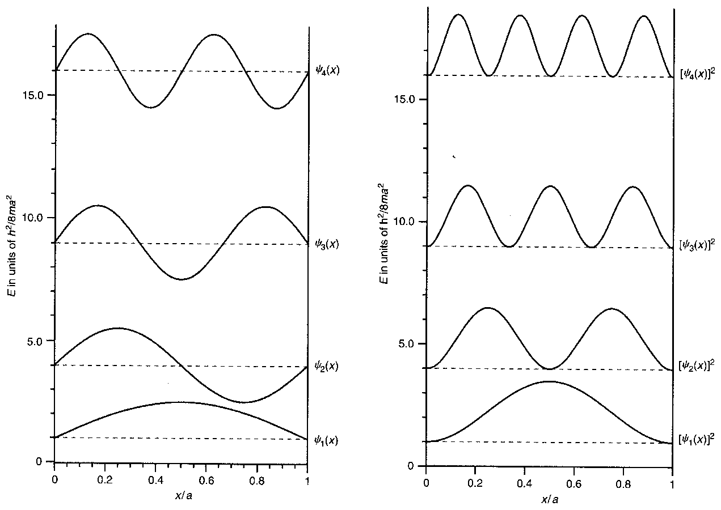

(9) The **position observable** (i.e., “x”) is **NOT something that can be precisely known** for the particle in a box wavefunction because the position operator,, **does not yield an eigenvalue equation** when it operates on the wavefunction, ψ(x), for the system:

i.e., ψ(x) ≠ (a real value) ψ(x); i.e., thus, we would obtain different values each time a measurement of position was performed.

(10) **However,** **we do have a way of determining the average position**, and for determining **the spread in this value**:

**Postulate 4** tells us how to determine the **average position, <x>,** and the **spread** in this value (**σx**) is obtained from the **variance** (σx2): (σx2) = <x2> ‒ <x>2:

E.g., What is the expected value for position for any eigenstate ψn(x), of a 1-D particle in a box?

Using Postulate 4,

$$⟨x⟩_{n}=\int_{0}^{a}{{\left[\sqrt{\frac{2}{a}}\text{ Sin}\frac{n⋅π⋅x}{a}\right]}^{*}(\hat{x}) \sqrt{\frac{2}{a}} }\text{Sin}\frac{n⋅π⋅x}{a}\text{ dx}=\frac{2}{a}\int_{0}^{a}{*\text{x }}\text{Si}{\text{n}}^{2}\left(\frac{n⋅π⋅x}{a}\right)\text{ dx}$$

Put y = nπx/a → dx = [a/nπ]dy, x = 0 ↔ y = 0, x = a ↔ y = nπ and use the standard

integral $\int{\text{y Si}{\text{n}}^{2}\left(y\right) }\text{dy}=\frac{y}{4}-\frac{\text{y Sin}\left(\text{2y}\right)}{4}-\frac{\text{Cos}\left(\text{2y}\right)}{8}$ to obtain

$$⟨x⟩_{n}=\frac{2}{a}{\left(\frac{a}{\text{n}\text{π}}\right)}^{2}{\int_{0}^{\text{n}\text{π}}{\text{y Si}{\text{n}}^{2}\text{y dy}=\frac{2}{a}{\left(\frac{a}{\text{n}\text{π}}\right)}^{2} \left[\frac{y^{2}}{4}-\frac{\text{y Sin2x}}{4}-\frac{\text{Cos 2y}}{8}\right]}}_{0}^{\text{n}\text{π}} \\ ⟨x⟩_{n}=\frac{2}{a}{\left(\frac{a}{\text{n}\text{π}}\right)}^{2}\left[\frac{{\left(\text{n}\text{π}\right)}^{2}}{4}-0-\frac{1}{8}-\left(0-0-\frac{1}{8}\right)\right]=\frac{a}{2}$$

i.e., the **most probable position** for the particle **for any of the eigenfunctions** is in the **middle of the box** (which is what we likely would have guessed!).

**To obtain a corresponding expression for <x2>n** , we need to evaluate an integral with x2 in the integrand. In this case, we use the substitution y = nπx/a and the standard integral

$$\int{y^{2}\text{ Si}{\text{n}}^{2}\left(y\right) }\text{dy}=\frac{y^{3}}{6}-\left(\frac{y^{2}}{4}-\frac{1}{8}\right)\text{Sin}\left(\text{2y}\right)-\frac{\text{y Cos}\left(\text{2y}\right)}{4}$$

to obtain

**∴**(σx2) = <x2> ‒ <x>2 = a2/12 – ½[a/nπ]2 =.

**∴ Can demonstrate the HUP applies for a particle in a box** since $\text{Δ}\text{x} \text{Δ}{\text{p}}_{x}=\frac{ℏ}{2}{\left(\frac{π^{2}n^{2}}{3}-2\right)}^{\frac{1}{2}}$.

This value is always . **Please check this is so now for values of n = 1, 10, 100.**

**3-D Particle in a box –** enables 2 more concepts to be introduced

Now particle is confined to a 3-D box with sides a, b, c. Wavefunction is of the form ψ(x, y, z), and the Potential Energy is of the form:

V(x) = 0 for 0 < x < a and V(x) = ∞ for x ≤ 0 and x ≥ a

V(y) = 0 for 0 < y < b and V(y) = ∞ for y ≤ 0 and y ≥ b

V(z) = 0 for 0 < z < c and V(z) = ∞ for z ≤ 0 and z ≥ c

In the region where V = 0, we have

$$-\frac{ℏ^{2}}{\text{2m}}\left[\frac{∂^{2}}{∂x^{2}}+\frac{∂^{2}}{∂y^{2}}+\frac{∂^{2}}{∂z^{2}}\right]⋅ψ\left(\text{x,y,z}\right)=E⋅ψ\left(\text{x,y,z}\right)\text{ where }\left[\text{bracket}\right] ≡\text{ Laplacian or }∇^{2}\text{operator.}$$

This DE is solved assuming that ψ(x, y, z) is a product of 3 functions each of which depends on only 1-variable, x, y or z, i.e.,

ψ(x, y, z) = X(x) Y(y) Z(z).

[Valid for confinement region and also valid if V(x, y, z) = Vx(x) + Vy(y) + Vz(z); to be used later too].

Substituting this expression for ψ(x, y, z) into the DE and dividing by X(x) Y(y) Z(z) yields

$$-\frac{ℏ^{2}}{\text{2m}}\left[\frac{1}{X(x)}\frac{d^{2}X(x)}{\text{d}{\text{x}}^{2}}+\frac{1}{Y(y)}\frac{d^{2}Y(y)}{\text{d}{\text{y}}^{2}}+\frac{1}{Z(z)}\frac{d^{2}Z(z)}{\text{d}{\text{z}}^{2}}\right]=E$$

where partial DE on LHS has been replaced by 3 terms, each a function of a different variable, x, y, or z.

Since the result is a constant, E **→ each component in the DE must yield a different contribution to E**,

**i.e., E = Ex + Ey + Ez** .

Hence, **the above DE can be separated into 3 DEs** each in a different variable x, y and z;

e.g., $-\frac{ℏ^{2}}{\text{2m}}\left[\frac{1}{X(x)}\frac{d^{2}X(x)}{\text{d}{\text{x}}^{2}}\right]=E_{x}$

and **each DE** **has exactly the same form** as the equation encountered **in the 1-D case**.

**∴ Solutions have the same form** X(x) = Ax Sin [nxπx/a] = $A_{x} \left\{\text{Sin }{\left(\frac{\text{2m}{\text{E}}_{x}}{ℏ^{2}}\right)}^{\text{1/2}}x\right\}$ and each **nx** (a non-zero integer) is one of the **3 quantum numbers** – now there is one q. number for each coordinate.

**Normalized wavefunction** is

$ψ\left(\text{x,y,z}\right)={\left(\frac{8}{\text{abc}}\right)}^{\text{1/2}}\text{Sin}\left[\frac{n_{x}\text{π}\text{x}}{a}\right]\text{ Sin}\left[\frac{n_{y}\text{π}\text{y}}{b}\right]\text{ Sin}\left[\frac{n_{z}\text{π}\text{z}}{c}\right]$ and substituted into the DE’s this gives

E = Ex +Ey + Ez = .

**This is a general result**: If the **total energy can be written as a sum of independent terms** each corresponding to different degree of freedom, then the **wavefunction is a product of individual terms**, each corresponding to **1 degree of freedom**.

**Degeneracy:**

For the particle in a 3-D box, the wavefunction and the energy depend on 3 quantum numbers. **What if a = b = c?** We’ll get the **same energy for many different combinations of the 3 quantum numbers**. For this we say that the energy level is **degenerate** and the **number of wavefunctions** (states) with the same energy is the **degeneracy** of the level (but note that each eigenfunction has only one eigenvalue).

If we went back to the situation where a ≠ b ≠ c, the overall symmetry would be broken and we’d say the **degeneracy has been “lifted.”** The special case when nx = ny = nz = 1 is called a **non-degenerate case**.

Note the following:

(1) The quantization conditions that arise come not only from solving the DE but also from the **boundary conditions** that apply: the wavefunction must vanish at the limits of the box, i.e., “quantization” has arisen naturally from the mathematical analysis.

(2) Since ψ(x, y, z) = 0 is not allowed everywhere (which would happen if n = 0 was allowed), we have non-zero and integer quantum numbers and hence a **zero-point energy**: according to QM, the **particle in a box can’t have a zero KE** whereas CP certainly allows that.

(3) **Technique of splitting Hamiltonian** into a sum of terms each dependent on 1 variable and of **factoring the wavefunction into product of terms** each dependent on 1 variable **is common in QM**.

**Let us review the Postulates (encountered in Section 5) with respect to a Particle in a Box:**

**1.** (State of the system is completely specified by the wavefunction).

Note a *wavefunction* is any mathematically well-behaved function that satisfies the boundary conditions and that can be normalized so as to give a meaningful definition of probability, whereas an *eigenfunction* also must satisfy an additional requirement. It must satisfy an operator equation. (E.g., φ (x) = c Sin(πx/a) + d Sin(2πx/a) satisfies the boundary conditions at x = 0 and x = a [it is 0 at those places] but it is **not** an eigenfunction of the **energy** operator)

In our case, all the wavefunctions can be normalized, i.e., the particle is somewhere in the box. However, we cannot predict with certainty the *position* of the particle from a single measurement. It turns out that **while the wavefunction is an eigenfunction of the total Energy operator it is NOT an eigenfunction of the Position operator**.

We will find out that the **operators** for Position and Energy **don’t commute** so we **cannot** obtain the corresponding Position and Energy eigenvalues **simultaneously**.

However, we can determine the **average value for position** found from a large number of independent measurements and we can find the **probability of finding the particle in a given region of space**. The procedure for doing this is given in Postulate 1 (i.e., for determining the probability density).

**Example: Determine the Probability of finding the particle in the 1st half of the box.**

**Answer given below.**

**2.** We used **Postulate 2** to obtain the QM operators.

**3.** and **4.** We have seen how these postulates apply: the only values ever observed in a single measurement are the eigenvalues of the corresponding operator (Postulate 3) and the average value for an observable is determined by the expectation value equation (Postulate 4).

E.g. for 1D-box, if ψ = ψ1(x) = (2/a)1/2Sin[πx/a], then applying the energy operator gives an eigenvalue equation with eigenvalue (h2/[8ma2] = the energy value for this state. In this case, the wavefunction is also an eigenfunction of the Energy operator so this eigenvalue is also the average value for this state.

What happens **if the system is not in one of the states** [ψ1(x) to ψn(x)] encountered above that are eigenfunctions of the Energy operator but rather is in a **superposition state** involving ψ1(x) and ψ2(x):

Ψ = (2/a)1/2{c Sin[πx/a] + d Sin[2πx/a]}.

If |c|2 + |d|2 = 1, this is a normalized wavefunction (see p. 54 of 1st; p. 60 of 3rd; p. 86 of 4th Ed.). A check shows this is not an eigenfunction of the Energy operator, (p. 53; p. 59; p. 85 of the 3 Eds.).

**Postulate 3** tells us that we will **still obtain one of the energy eigenvalues** but since the superposition state is not an eigenfunction of the Energy operator, we **don’t know which eigenvalue** we will measure, it could be E1 or it could be E2.

**Postulate 4** tells us how the average value can be determined and since the superposition state is a superposition of 2 functions that are eigenfunctions of the Energy operator, we know the probability of obtaining specific values:

|c|2 gives us the probability of getting E1 and

|d|2 gives us the probability of getting E2.

Hence the average energy value observed, <E>, is |c|2 E1 + |d|2 E2 [where En = n2h2/(8ma2)].

While it was not possible to predict whether E1 or E2 would be observed, if the energy was measured again on the same system, the same result will be obtained as in the original measurement and the same result would apply for all subsequent measurements! Suggests that the measurement process has **forced** the system into an eigenfunction of the operator corresponding to the quantity being measured!

It can be shown that the average linear momentum (<px>) for all particle-in-a-box energy wavefunctions = 0 yet we know all these states have an energy and since V = 0, **this energy must all be kinetic energy**, ½ m v2 = px2/2m. **How can this be?**

Well, it is equally likely that the particle is moving in the +ve x-direction as in the –ve x-direction so the **average linear momentum can be zero**. This gels with the CP picture. However, whereas in CP, the linear momentum is known with certainty (=2mEkin)1/2, in QM ***only the average*** **value for the linear momentum is known** (it is 0), and there is ***some uncertainty* in that knowledge as well.**

[Can be shown that (Δpx)n = nh/(2a)].

**Example: Determine the Probability of finding the particle in the 1st half of the box.**

Solution is given by

$$P=\int_{ 0}^{ a/2}{{\left[\sqrt{\frac{2}{a}} \operatorname{Sin}{ }\left(\frac{n π x}{a}\right)\right]}^{*}\sqrt{\frac{2}{a}}\operatorname{Sin}{ }\left(\frac{n π x}{a}\right) dx}$$

Can be solved by substituting y for nπx/a and from ∫Sin2y dy = y/2 – ¼ Sin 2y.

Should get P = 0.5 i.e., we predict that in a large number of measurements, 50% of the time we would find the particle in the 1st half of the box.

**The Particle in the Box and the Real World**

Now the box is modified so V=V0 (finite depth & not ∞) outside the V = 0 confinement-region. To simplify the math, the limits are –a/2 to a/2 for this region. Allows particle to escape. See Text Ch. 5.

**SWE inside the box** is the same as before and the ψn(x) have the oscillatory behavior inside the box (see diagram) but now the wavefunctions ψn(x) are not zero at the limits because V becomes V0 (≠ ∞) there.

**SWE outside the box** has the form

 & solutions in this region are of the form ψ(x) = Ae-κx + Beκx where . To obtain the overall ψ(x), need to match the ψ(x), and their derivatives at the boundary positions and impose a Normalization condition. Result is that now there are only a finite number of bound states (the number depends on m, a, and V0) and the wavefunctions **do not** have 0 “amplitude” at the edges of the box. Shaded region defines the **classically forbidden region, Ekin<0**.

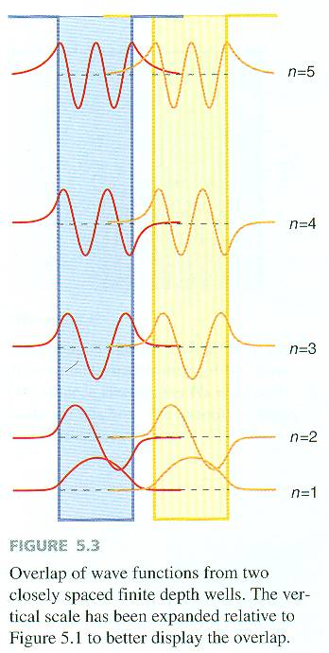

***Serves as a model for understanding*:**

* 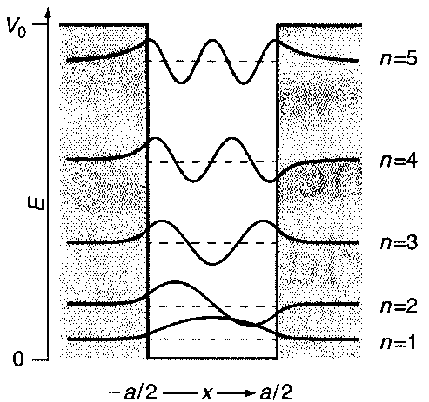the difference between core and valence electrons;
* how bonding between atoms can occur;
* Pi electron behavior in conjugated molecules (a PC Expt.);
* electrical conductivity (conduction band, band gap;
* QM Tunneling and Tunneling in Chemical Reactions; and
* more esoteric systems and recently utilized phenomena such as the Scanning Tunneling Microscope (STM), Atomic Force Microscope (AFM), Quantum Wells, certain types of lasers, and Quantum Dots (e.g., CdSe).
* Please see Textbook Chapter 5 for complete details.

**Core & Valence Electrons**

Real World Particle in a Box model serves as a crude model for electrons in an atom:

* + Weakly bound states have wave functions that “leak’ quite strongly into the region outside the box & correspond to **Valence electrons**
  + Strongly bound levels correspond to **Core electrons**

What happens when a 2nd atom is brought close enough to form a chemical bond? See the PE diagram that shows the overlap of wavefunctions from 2 closely-spaced, finite-depth wells **⇒**

* Wavefunctions for strongly bound levels (Core electrons) give rise to small overlap whereas
* Wavefunctions for weakly bound states (Valence electrons) give rise to significant overlap

**Delocalized π-Electrons in Conjugated Molecules – model**

Absorption of light results from exciting electrons in molecules from the highest occupied molecular orbital (HOMO) energy level to lowest unoccupied (LUMO) energy level. If electrons are delocalized in an organic molecule with a π-bonded network, the absorption maximum shifts to lower energy (from UV to Visible and even from blue to red).

The π-bonded electrons can be described reasonably well by a particle in a box model. Each energy level can have 2 electrons. The energy level spacing depends on the length of the π-bonded network

{, where m=mass of the electron and a is the network length} and the observed λmax can be used to estimate an “apparent” a (p. 71 3rd Ed.; p. 97 of 4th Ed.). Equation shows λmax ∝ a2; as confirmed by experiment (see Table below) where λmax = 345, 375, 390 nm & ni = 2, 3, 4.

Note, a calculation in the Text shows that higher lying levels are not populated at room temperature due to translational energy (uses the Boltzmann distribution): all molecules are in their electronic ground state.

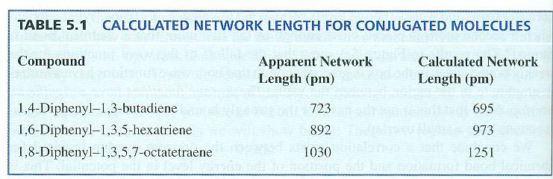

**Particle in a Box and Quantum Mechanical Tunneling (5.6, 5.8 of 4th Ed.)**

If the PE barrier is thin, the particle can escape through the barrier even though it does not have sufficient energy to go over the barrier! Known as Quantum Mechanical Tunneling. Treatment in Text shows the particle has a finite probability of escaping from the well and through the barrier even though its energy is less than the barrier height. Tunneling is much higher for particles with higher energies. Extent depends on the decay length which is the inverse of κ encountered earlier (1/κ) =.

**Tunneling at a step potential**

e.g., an electron entering a –vely charged capacitor at potential V. Considered in 2 regions, where V =0 and where V=V0. Need to consider the possibility the particle will be reflected at the barrier. Classically T=1, R=0 for E≥V and R=1, T=0 for E<V, but QM’ly R →1 as E→V & R→0 asymptotically for E>>V.

**Tunneling through a Barrier**

Classically, can’t pass at V>E but not so QM’ly. Tunneling more extensive as E → V. Due to the degree to which the wavefunction in the barrier falls off with distance as exp(–κx) where 1/κ is the decay length.

**Tunneling in Chemical Reactions**

e.g., H transfer reactions; test: substitute D for H. If the reaction is thermally activated, the change in rate is small (attributable to the different ground state vibrational frequency of –OH and –OD) but if tunneling occurs, the rate decreases greatly because it depends exponentially on the decay length, . Can also be important for heavier atoms such as C & O – e.g. in the text of rate being 10152 faster at 10 K due to tunneling where heavier atom tunneling becomes appreciable if V0-E is very small (p. 62 3rd Ed).

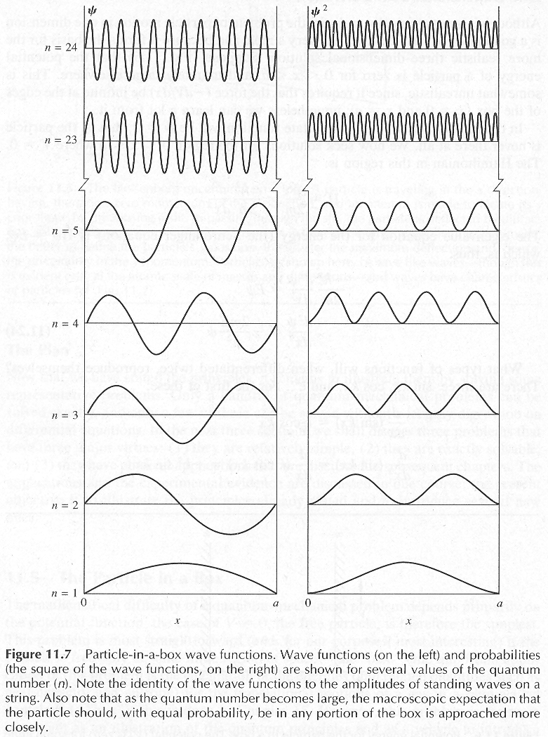**Correspondence Principle**The Figure above, demonstrates the **Bohr Correspondence Principle**: the **results from Quantum Mechanics approach results from Classical Physics in the limit of large Quantum Numbers**. As the quantum number n → ∞, the particle has an equal probability of being anywhere in the box.

**Let us see what this 1-D box tells us about certain systems:**

The **energy of an electron in a 1-Bohr wide box** =. Providing this expression in units of hartrees (the unit of energy in atomic units – more about those later), where , we have

, which is 4.98348 h or 2.15×10‒17 J or 1.296 × 107 J/mole =134 eV), which is **a sizable amount of energy**.

Doing the same calculation for a much more massive **proton** (1836 times the mass of an electron), for the same width box, the result would be **much less**: 0.00269 h for n=1 (7057 J/mole, 0.0731 eV).

Doing the same calculation for an **electron in a wider 10 a0 box** results in a **much smaller energy** (0.0493 h, 130 kJ/mole, 1.34 eV for n = 1).

When we move to **macro-sized systems such as for a 1-gram particle in a 1 cm wide box**, the energy determined is **too small to be meaningful**, 3.3 × 10–37 J/mole.

**Note: The hartree energy unit:**

The definition of energy unit hartree is twice the ionization energy of atomic hydrogen. For simplicity at this stage, we will use the mass rather than the reduced mass for this system.

Thus, .

The Bohr radius, the atomic unit of length (again using mass rather than the reduced mass), a0, is the radius of the 1st Bohr orbit in the Bohr model of the H atom, i.e., when n =1 in Bohr’s formula. That is, 

so  .

[1 hartree ≡ 4.3597 × 10–18 Joules ≡ 2.1947 × 105 cm–1 ≡ 27.2114 eV (since 1 eV = 1.602177 × 10–19 J)].

(See CODATA Recommended Values Tables on Canvas for 2018 Conversion Values).